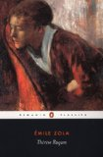 | Thérèse Raquin is a story of the consequences faced by the lovers Thérèse and Laurent who murder Thérèse's husband Camille. The lovers conceal their crime and manage to escape the justice system, but find their own punishment in the course of their terrible marriage.  Thérèse comes to live with her sickly cousin Camille as a small child. His mother, Madame Raquin, subjects Thérèse to the same treatments as her precious son. When they are old enough, Thérèse and Camille marry. Camille insists that they move to the city. Madame Raquin purchases a dilapidated shop for her children in a disreputable part of town. Thérèse is resigned to her dull life with her disgusting husband. Camille finds a job and Madame Raquin helps Thérèse run the shop. On Thursdays, Madame Raquin entertains a few friends. Laurent, a childhood friend to the couple, starts visiting the family regularly. Laurent kisses Thérèse the first chance he gets alone with her, beginning a passionate love affair. To be together, Laurent takes time off work, and Thérèse pretends to have headaches to give her leave from the store. Their affair continues for months, until Laurent risks losing his job if he takes off any more time from work. Thérèse visits his tiny room one evening. They long for Camille to be gone so that they can be together. Laurent decides to kill Camille.
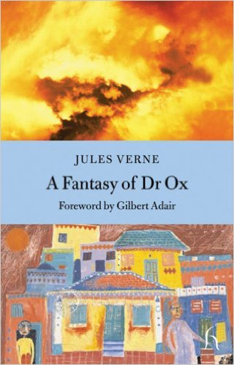 | Something very strange is in the air of the harmonious town of Quiquendone. Unknown to its inhabitants, the mad genius Dr. Ox has unleashed a veil of oxyhydric gas over the town—his own living laboratory—in an attempt to spice things up. In his amusing portrait of an idyllic community suddenly overtaken by an appetite for aggression, Jules Verne points to the ease with which any society—and the modern resonance is unmissable—can be manipulated by its masters into hatred and war. Jules Verne was the originator of modern science fiction; among his works are Around the World in Eighty Days and Journey to the Center of the Earth. (less)
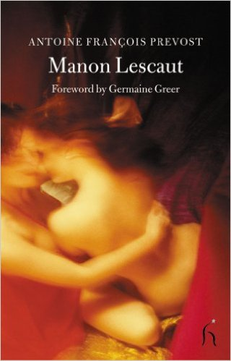 | The young Chevalier des Grieux, a student of philosophy in Amiens, becomes friendly with a fellow student named Tiberge. One day, he stands idly with his friend and watches the arrival of the Arras coach. Among the passengers is a beautiful young woman, who attracts the chevalier’s attention. Politely introducing himself, he learns that her name is Manon Lescaut and that she has come to Amiens under the protection of an elderly man. Against her will, she is to enter a convent. She accepts the chevalier’s offer to set her free from that fate, and after skillfully and untruthfully disposing of her escort, she accompanies the young student to an inn. They plan to flee to Paris the next day. Tiberge argues with his friend against this folly, but the chevalier is hopelessly infatuated. In Paris, he and Manon take a furnished apartment, where for three weeks they are absorbed in each other.
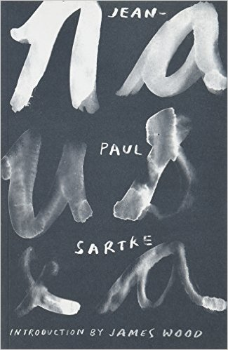 | "Nausea" is both the story of the troubled life of an introspective historian, Antoine Roquentin, and an exposition of one of the most influential and significant philosophical attitudes of modern times - existentialism. The book chronicles his struggle with the realisation that he is an entirely free agent in a world devoid of meaning; a world in which he must find his own purpose and then take total responsibility for his choices. A seminal work of contemporary literary philosophy, "Nausea" evokes and examines the dizzying angst that can come from simply trying to live.
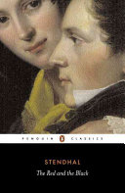 | Handsome, ambitious Julien Sorel is determined to rise above his humble provincial origins. Soon realizing that success can only be achieved by adopting the subtle code of hypocrisy by which society operates, he begins to achieve advancement through deceit and self-interest. His triumphant career takes him into the heart of glamorous Parisian society, along the way conquering the gentle, married Madame de Rênal, and the haughty Mathilde. But then Julien commits an unexpected, devastating crime - and brings about his own downfall. The Red and the Black is a lively, satirical portrayal of French society after Waterloo, riddled with corruption, greed and ennui, and Julien - the cold exploiter whose Machiavellian campaign is undercut by his own emotions - is one of the most intriguing characters in European literature.
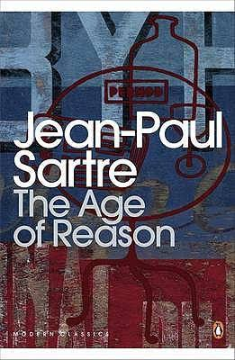 | The first volume in his Roads to Freedom trilogy, Jean-Paul Sartre's The Age of Reason is a philosophical novel exploring existentialist notions of freedom, translated by Eric Sutton with an introduction by David Caute in Penguin Modern Classics. Set in the volatile Paris summer of 1938, The Age of Reason follows two days in the life of Mathieu Delarue, a philosophy teacher, and his circle in the cafés and bars of Montparnasse. Mathieu has so far managed to contain sex and personal freedom in conveniently separate compartments. But now he is in trouble, urgently trying to raise 4,000 francs to procure a safe abortion for his mistress, Marcelle. Beyond all this, filtering an uneasy light on his predicament, rises the distant threat of the coming of the Second World War. Jean-Paul Sartre (1905-1980) was an iconoclastic French philosopher, novelist, playwright and, widely regarded as the central figure in post-war European culture and political thinking. Sartre famously refused the Nobel Prize for literature in 1964 on the grounds that 'a writer should not allow himself to be turned into an institution'. His most well-known works, all of which are published by Penguin, include The Age of Reason, Nausea and Iron in the Soul. If you enjoyed The Age of Reason, you might like Sartre's Nausea, also available in Penguin Modern Classics. 'For my money ... the greatest novel of the post-war period' Philip Kerr, author of the Berlin Noir trilogy
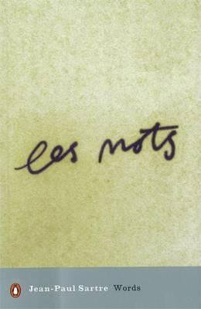 | Jean-Paul Sartre was arguably the best-known and most influential French writer of his time. As a philosopher, as a novelist, as a playwright, as the author of filmscripts, as the editor of Les Temps Modernes, as a man who was never afraid to commit himself to the moral and political as well as the literary life of his own times, he was unique. Not since Voltaire has Western civilization produced so humane, manifold, and boldly "engaged" a man of letters. At 59, he undertook his autobiography, bringing to his own childhood the same rigor of honesty and insight which he had applied so brilliantly in earlier books to Baudelaire and Jean Genet. "Directed to the heart as well as to the intellect," the result is like nothing else in the Sartre canon, or in France, where The Words has been accorded a place beside that other masterpiece of self-analysis, Rousseau's Confessions.--Adapted from publisher description.
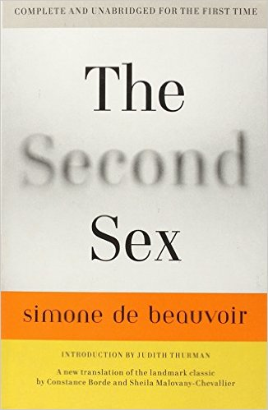 | Simone de Beauvoir's masterwork is a powerful analysis of the Western notion of “woman,” and a groundbreaking exploration of inequality and otherness. This long-awaited new edition reinstates significant portions of the original French text that were cut in the first English translation. Vital and groundbreaking, Beauvoir's pioneering and impressive text remains as pertinent today as it was sixty years ago, and will continue to provoke and inspire generations of men and women to come
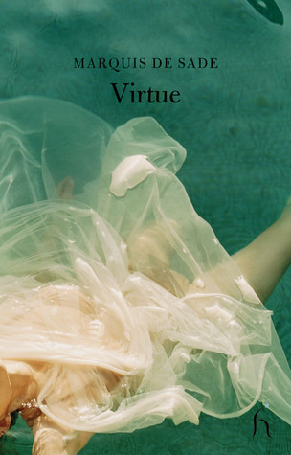 | Herman and the noble and proud Ernestine, two young lovers find themselves confronted with a pair of libertines who will stop at nothing-not even the confines of the law-to assuage their desires. Count oxtiern, villainous and dissolute, and his accomplice Madam Scholtz, widow of lusty temperament, will shrink from no lie, no treachery, in their quest for sexual fulfillment. But does crime really never pay? Or can virtue vanquish vice?
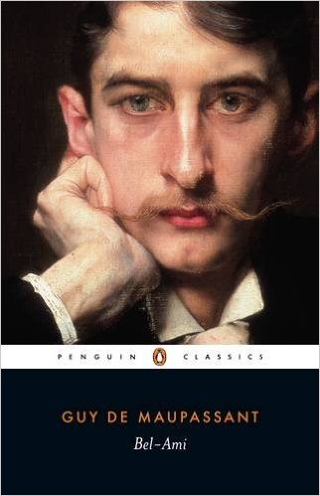 | Young, attractive and very ambitious, George Duroy, known to his friends as Bel-Ami, is offered a job as a journalist on La Vie francaise and soon makes a great success of his new career. But he also comes face to face with the realities of the corrupt society in which he lives - the sleazy colleagues, the manipulative mistresses and wily financiers - and swiftly learns to become an arch-seducer, blackmailer and social climber in a world where love is only a means to an end. Written when Maupassant was at the height of his powers, Bel-Ami is a novel of great frankness and cynicism, but it is also infused with the sheer joy of life - depicting the scenes and characters of Paris in the belle epoque with wit, sensitivity and humanity.  For more than seventy years, Penguin has been the leading publisher of classic literature in the English-speaking world. With more than 1,700 titles, Penguin Classics represents a global bookshelf of the best works throughout history and across genres and disciplines. Readers trust the series to provide authoritative texts enhanced by introductions and notes by distinguished scholars and contemporary authors, as well as up-to-date translations by award-winning translators
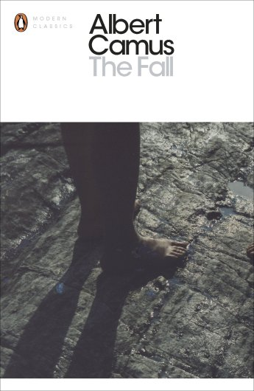 | The Fall (La chute, 1956; translated from the French by Robin Buss) is one of those interesting and rewarding pieces of work that reminds one that it can be an excellent idea to begin one’s acquaintance with a very famous, but to you unfamiliar author, with one of their less well-known efforts. Consider Joseph Heller’s Something Happened, John Updike’s The Coup, or Vladimir Nabokov’s Pnin in the same spirit. As it turned out, The Fall was Albert Camus’ last published work due to a fatal car crash in 1960. It had apparently been designed as a transition piece and was written as the country in which he lived, France, was becoming deeper engaged in an obscenely violent colonial war in the land of his birth, Algeria, and when the hopes of the young were being extinguished by Soviet tanks in Budapest. e shall never know how the transition might have developed. This is a novella funny and deeply serious in turns, drenched in layer upon layer of Christian symbolism and replete with the most serious questions of sin, redemption, and mortality. Like much fine literature, it is content to pose questions and seldom ventures to provide answers. Heady stuff indeed, but sprightly prose and a short length ensures success on far less consequential levels too.
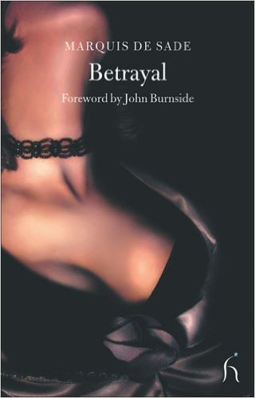 | The Baron de Teroze has already successfully married off his eldest daughter to a colonel of the dragoons; now it is time for him to arrange his younger daughter's nuptials. A corrupt magistrate from Aix seems to him the ideal candidate, much to the disgust of the young Mademoiselle de Teroze, who is in love with another man. Vowing to rid the beautiful marchioness of her odious old husband, her lover, sister and brother-in-law conspire in a series of hilarious manipulations that ultimately results in complete humiliation and defeat for their hapless guest. As a companion piece to "The Mystified Magistrate, " "Emilie de Tourville" tells the chilling story of another unfortunate younger sister, whose elder, lawyer brothers exact revenge on her for compromising their family's honour. Two of the Marquis de Sade's most elegant tales of love and deception, these pieces offer a scandalous glimpse into his society's hidden proclivities and a shocking indictment on the rising bourgeoisie.
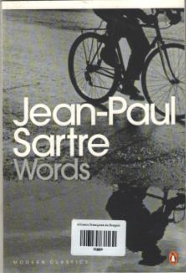 | Jean-Paul Sartre's famous autobiography of his first ten years has been widely compared to Rousseau's Confessions. Written when he was fifty-nine years old, The Words is a masterpiece of self-analysis. Sartre the philosopher, novelist and playwright brings to his own childhood the same rigor of honesty and insight he applied so brilliantly to other authors. Born into a gentle, book-loving family and raised by a widowed mother and doting grandparents, he had a childhood which might be described as one long love affair with the printed word. Ultimately, this book explores and evaluates the whole use of books and language in human experience.
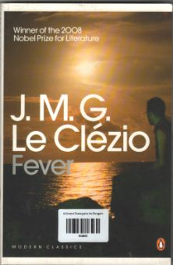 | Explores how the physical sensations we experience can be as strong as feelings of love or hate, with their power to bring chaos to our lives. This title features tales such as The Day that Beaumont became Acquainted with his Pain, Fever, and A Day of Old Age. It portrays the landscape of the human consciousness

